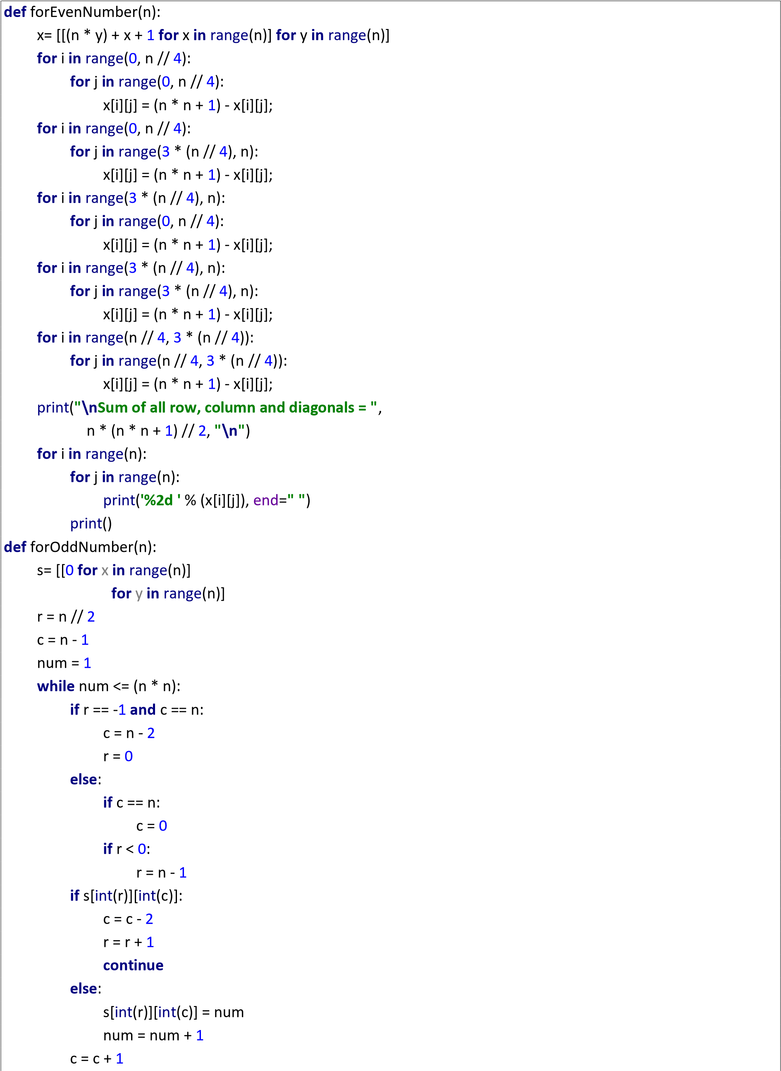

r = r

-

1

print

(

**"**

**\**

**n**

**Sum**

**of all row, column and diagonals = "**

,

n * (n * n +

1

)

//

2

,

**"**

**\**

**n**

**"**

)

**for**

i

**in**

range

(

0

, n):

**for**

j

**in**

range

(

0

, n):

print

(

**'%2d '**

% (s[i][j]),

end

=

**''**

)

print

()

print

(

**"**

**\**

**n**

**WELCOME:)**

**\**

**n**

**"**

)

print

(

**"THIS PROGRAM RETURNS SAME**

**SUM OF EACH ROW, COLUMN AND DIAGONAL!"**

)

print

()

n =

int

(

input

(

**"Please Enter Number of Rows and Column (n*n): "**

))

**if**

n%

2

==

0

:

forEvenNumber(n)

**else**

:

forOddNumber(n)

print

(

**"**

**\**

**n**

**Thank you :)"**

)